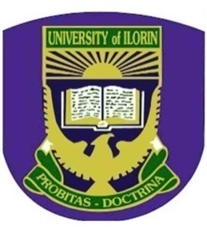**UNIVERSITY OF ILORIN** PGS Form 16A (2019)

**POSTGRADUATE SCHOOL**

**CANDIDATE’S PASSPORT PHOTOGRAPH SNAPPED ON RED BACKGROUND**

**ONLY**

**COLLECTION OF POSTGRADUATE DEGREE CERTIFICATE**

Kindly release to me my Degree Certificate

Name:………………………………………………………………………………

(Surname first)

Degree:……………………….……………………………………………………………..

Course:……………………………………………………………………………………...

Department:…………………………………………………………………………………

Year of Graduation:…………………………………………………………………………

Date of Collection:………………………………………………………………….............

Signature of Student:………………………….. Phone No:………………………………..

**Please note the information below for necessary guidelines**

**Collection of Certificate**

* Evidence of payment receipt for the convocation charges
* Original Notification of Result. Sworn Affidavit and Police Report in case of loss
* Student’s Identity Card, Sworn Affidavit and Police Report in case of loss

**Collection of Corrected Certificate**

* One Passport Photograph
* Photocopy of certificate submitted for correction

**Collection by Proxy (Status): Deans, Directors, HOD, PG Coordinator and Deputy Registrar**

* Original statement of Result/Notification of Result
* Student’s Identity Card
* A passport photograph of the candidate and that of the proxy
* Suitably typed letter, phone No of proxy and candidate

**OFFICIAL USE ONLY**

Statement of Result, Notification of Result/Certificate No:………………………..............

Name:……………………………………………………………………………………….

(Officer authenticating application)

Designation:…………………………………………………………………………….......

Date:………………………………………………………………………………………...

Phone Number:……………………………………………………………………………