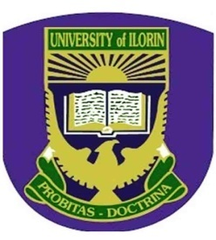UNIVERSITY OF ILORIN

POSTGRADUATE SCHOOL

**CANDIDATE’S PASSPORT PHOTOGRAPH**

**ON RED BACKGROUND**

**ONLY**

**PROXY’S**

**PASSPORT**

**PHOTOGRAPH**

**ON RED BACKGROUND**

**ONLY**

COLLECTION OF POSTGRADUATE DEGREE CERTIFICATE

I, ……………………………………………………………………………

**Full Name (Proxy)**

Address………………………………………………………………………

Department/Unit ……………………………………………………………

**(UNILORIN Member of Staff only)**

Personal File Number …………………………………………………………

**(UNILORIN Member of Staff only)**

Mobile Telephone Number:………………………………………………..

E-mail Address:………………………………………………………………

Do hereby agree to physically collect the certificate of

1. Full Name of Graduand:……………………………………………….
2. Matriculation Number:…………………………………………………
3. Degree Awarded:……………………………………………………….
4. Department:……………………………………………………………..
5. Faculty:………………………………………………………………….
6. Year of Graduation:……………………………………………………..
7. Date of Collection:……………………………………………………….

That I further agree that if the certificate of the above named graduand is collected by me. I agree that the University shall not for whatever reason be liable to be responsible for as at when due, my failure to deliver the Certificate or for any damage done to it in transit.

……………………………………….. …………………………………..

**Signature** **Date**

**NOTE:**

Kindly attach the Letter of authority (suitably typed) given to you by the candidate alongside with his/her University of Ilorin Identity Card.